Note;
A new uploaded Project is not shown in the Edit View bevor a WBS Element and a Hierachie is added to he project

- Open Fiori an Download:
  - Project Definition - Attributes
  - Project Definition - Language-Dependent Texts
  - WBS Element - Attributes
  - WBS Element – Hierachies
  - WBS Element - Language-Dependent Texts

- Open Project Definition – Attributes file and add a new project

Note:
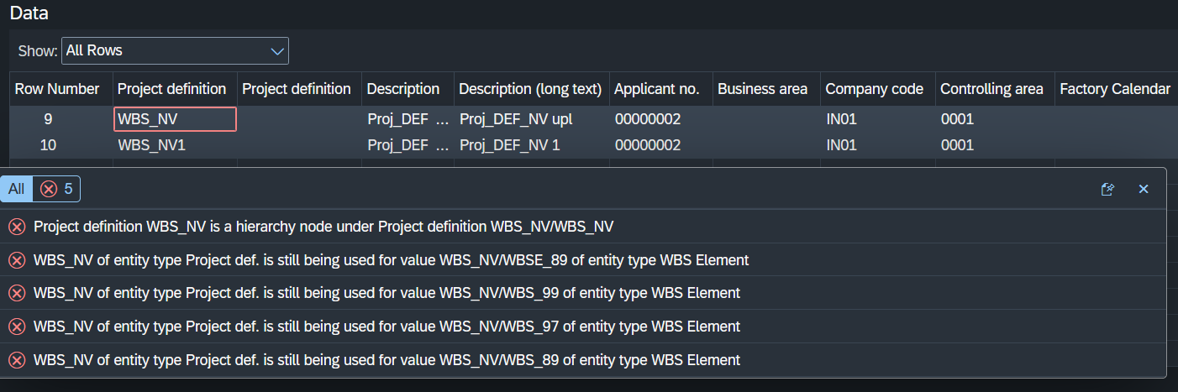
Upload new Project is possible, change old project description is not possible

Project deinition 2 times! PSPID;PSPNR; Work Breakdown Structure Element (WBS Element); WBS Element ?????????
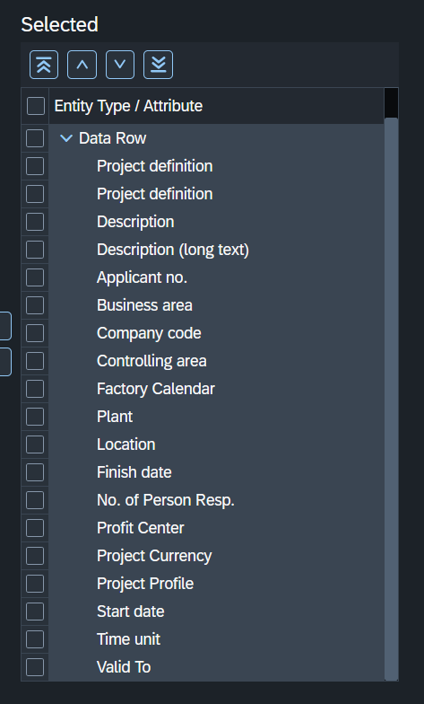

- Upload with CR: Load Work Break Struc. and activate
- Open Project Definition – Language-Dependent Texts file and add a new Language
- Upload with CR: Load Work Break Struc. and activate
- Check changes
- Open the WBS Element - Attributes file and add a new WBS Elements
- Add new WBSE for a existing Project and for the new Project

